North Yorkshire Youth Privacy Statement

North Yorkshire Youth (NYY) is an organisation supporting children and young people across North Yorkshire. As providers of support services, we are required to process personal data about the young people we support, their parents/legal guardians, and sometimes, other relatives or friends. “Processing” means collecting, recording, organising, storing, sharing, or destroying information (data).

This privacy notice is about the data we collect and process about you.

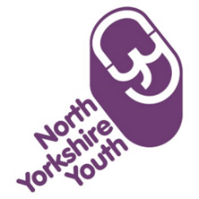 | Who are you?  North Yorkshire Youth is a charitable organisation that provides opportunities for children and young people to reach their potential. We are working in partnership with Woodsmith Education Programme (Anglo American) which aims to support young people’s personal development, aspirations, learning and attainment. Our website address is www.nyy.org.uk and our partner’s website address is: www.angloamerican.com/the-woodsmith-project
We will be providing a range of services to your school including trips and visits, and extra-curricular activities. Everything we do will be agreed by your school in advance. One of the main things we will provide is Youth Mentoring.

What is a youth mentor?
Youth mentors are trusted adults who support young people by creating programmes to improve their well-being, and by providing a role model that can help them in school and socially. Think of it as a buddy who can encourage and challenge you to be your best! We’re very experienced youth mentors, with 80 years of experience.

What information will you collect about me?
You may be asked about how you feel about certain things. We will collect information like your name, address, and other contact data. We may also collect information about your hobbies, homelife, school life, interests, feelings, and challenges; or other relevant data shared by you, or other people involved in your life or care.

Why do you want to know this?
In order that we can best support young people, we need to know a few things about them. For example, we might ask about what motivates or excites you; so that we can encourage you. We might ask about what upsets or worries you; so that we can support you about those things, and so on.

How will you use my information?
We use your information in order to provide services to you in the best possible way to support your personal development, aspirations, learning and attainment. This is used through our Youth Mentor service, or when additional support that cannot be met by this service may involve referral for additional support or alternative agencies may be requested to ensure the most appropriate and effective service is provided to you. This process may include passing on your information without your consent in relation to our statutory duty to do so, in order to protect you, prevent harm, or prevent a crime.

How will you collect this information?
We collect data from you, and other people involved in your life or care via face to face contact, phone, video conferencing, social media, email, our website, and the post.

How do you keep this information?  Your information will be kept safe on a special computer system called MyMup which is a secure, digital platform that can only be accessed by NYY staff.  Sometimes we may need to record your data outside of MYMUP, for example, to record an accident, incident, complaint or safeguarding concern or disclosure. In these circumstances will use our own organisation’s secure system.  Your rights:  - You have the right to ask us to correct any data we have about you which is inaccurate or incomplete.  - You have the right to request a copy of the data we have about you. Please speak to a member of staff if you want a copy of your data or email us at info@nyy.org.uk  - You have the right to ask us to delete any of your data which is no longer needed for the purpose we collected it. We will delete it unless we have a legal duty to retain it. We will tell you if this is the case.  - You have the right to log a complaint with the Data Commissioner’s Office if you have any concerns about how we are using your data. You can do this via their website, https://ico.org.uk/concerns/ or by calling their helpline 0303 123 1113.  How long will you keep the information?  Will keep the information for as long as we have meaningful relationship with you and for up to a maximum of 10 years. After that we will destroy it. |  |  | 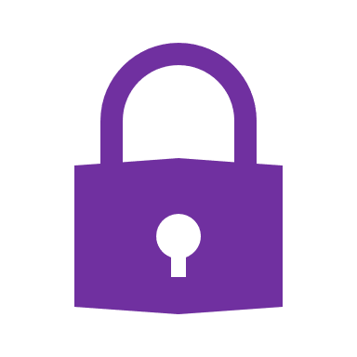

Are you allowed to do this? (‘legal basis for processing’)
We are allowed to do this because you, and your parent or carer, has given consent to it when you signed up for the Inspire-Achieve Programme. We also process your information under legal basis, this applies in circumstances where we have a statutory duty in order to protect you, prevent harm, or prevent a crime. We can collect the information if we look after it carefully and don’t share it with anyone who should not see it.

Who gets to see the information?
Only limited staff from North Yorkshire Youth are allowed to see the information you provide. Sometimes we may need to share your data with other trusted people involved in your life or care. We will only do this if it is absolutely necessary. Examples of trusted people we may need to share your data with are health workers, social workers/social services, youth workers, the police, or your school. If you tell us something that makes us think you are in danger, we will have to tell the relevant authorities.

We will send anonymous reports (about how our programme is going) to the Woodsmith Education Programme and to your school. ‘Anonymous’ means no-one will be able to identify you from the reports. They might say things like “half of the young people we have worked with feel a bit more motivated to join an after school club” and so on. The names of the young people taking part will not be included in these reports.

