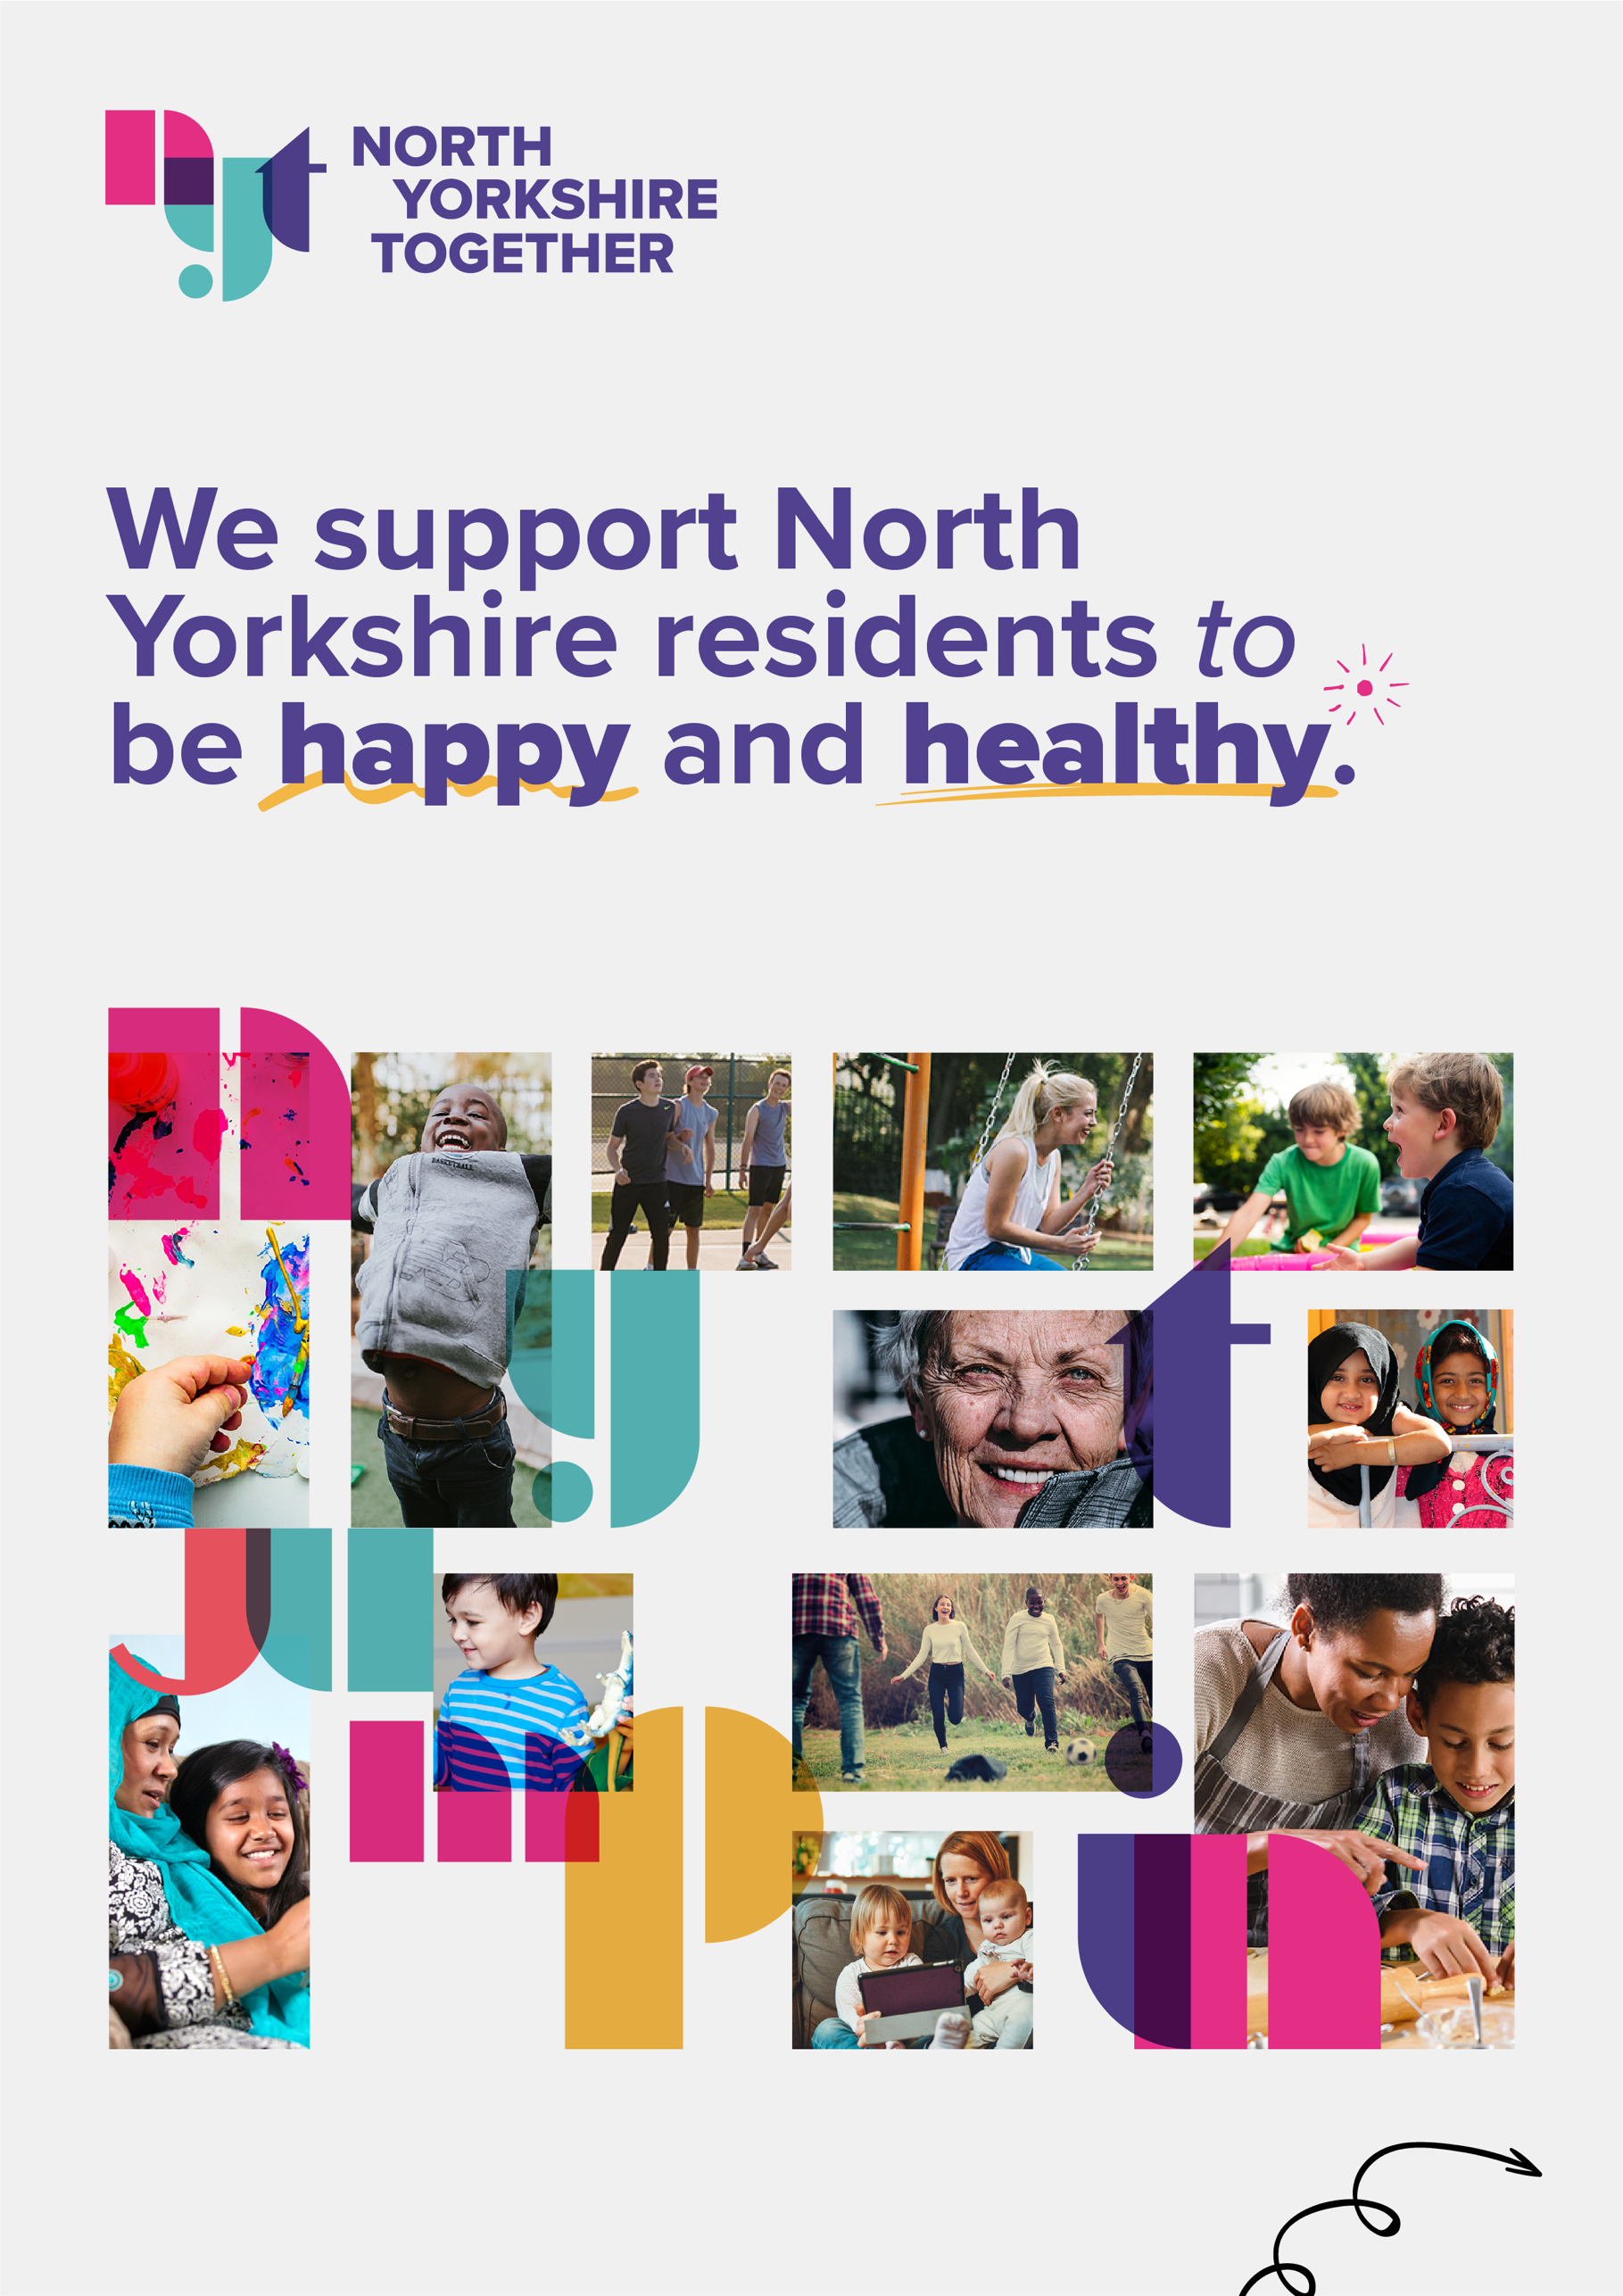

Welcome from North Yorkshire Together

Hello, and thank you for your interest in joining North Yorkshire Together.

North Yorkshire Together is a partnership between North Yorkshire Sport, North Yorkshire Youth and Rural Arts. We support communities across the county to feel happy and healthy.

Currently we’re leading programmes to support children on Free School Meals and refugees, and are a partner on Village Green, a North Yorkshire wide community-led climate change initiative.

We’re excited to be recruiting a Head of North Yorkshire Together to lead and develop our partnership into its next chapter. We currently support over 5,000 people each year, and believe our work is needed now more than ever.

We’re looking for someone with exceptional leadership and management skills, as well as experience working with across the VCSE sector, preferably within North Yorkshire. You will champion partnership working, embrace innovation and understand the changing landscape of local government, Trusts & Foundations and more.
As a senior leader, you will provide inspiration and direction to staff working on North Yorkshire Together projects across a number of organisations. You will also increase the profile of North Yorkshire Together and seek new opportunities for the partnership, extending our impact and visibility.

From a personnel perspective, you will be directly employed by North Yorkshire Sport, however you will engage with team members from across organisations on a daily basis to work cohesively. You will report jointly to the CEOs of North Yorkshire Sport, North Yorkshire Youth and Rural Arts.

We look forward to receiving your application, which we’re asking you to submit by 5pm on Thursday 12th February 2026.

Best wishes,

The CEOs of North Yorkshire Sport, North Yorkshire Youth and Rural Arts

About Us:

North Yorkshire Together

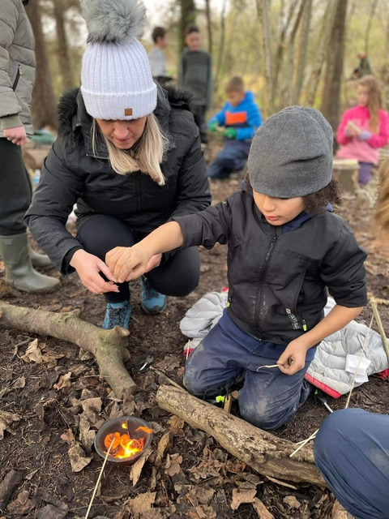
North Yorkshire Together is a partnership between North Yorkshire Sport, North Yorkshire Youth and Rural Arts. We support communities across the county to feel happy and healthy.

The partnership emerged during the pandemic as an emergency response programme, funded by the National Lottery Community Fund. We delivered thousands of activity packs, digital devices and bursaries to thousands of those most impacted by the pandemic, alongside a free to access online arts programme for people of all ages.

Since 2021, North Yorkshire Together has delivered FEAST, the Holiday Activities and Food (HAF) Programme in North Yorkshire, on behalf of North Yorkshire County Council, funded by the Department for Education. The HAF programme enables children on benefits-related Free School Meals to access food and enriching activities during the Easter, Summer and Christmas holidays. We work with 100+ brilliant organisations from across the community, educational and private sector, to deliver tens of thousands of free spaces – and meals – a year.

We also deliver enriching activities for refugees in Northallerton and Selby, and are a partner on Village Green, a three-year project putting communities at the heart of climate action in North Yorkshire

As a partnership of three cross-sector, cross county organisations, our partnership provides a robust, unique and far-reaching framework and delivery model to make real change across North Yorkshire. We believe firmly in our shared values, and the art of the possible.

North Yorkshire Sport

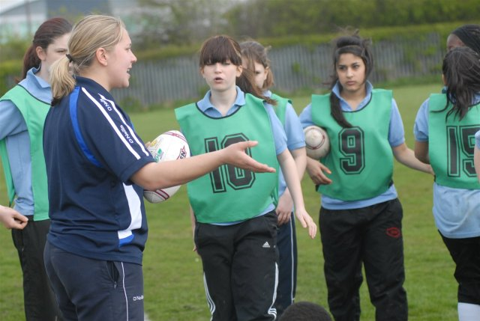

North Yorkshire Sport is a registered charity and the Active Partnership for North Yorkshire and York. We use movement, activity and sport as drivers for positive change. We want North Yorkshire and York to be a place where everyone enjoys moving more, leading to healthy and happy lives.

Our work is primarily focussed on supporting and influencing wider systems to use movement, activity and sport to improve people’s health and wellbeing. This includes partnership working with a wide range of organisations, from Sport England to Local Authorities, as well as the voluntary and commercial sectors. To support this work, we run a number of direct delivery programmes countywide as well as at our own facility in Harrogate, the Bilton Health and Wellbeing Hub.

Find out more at www.northyorkshiresport.co.uk

North Yorkshire Youth

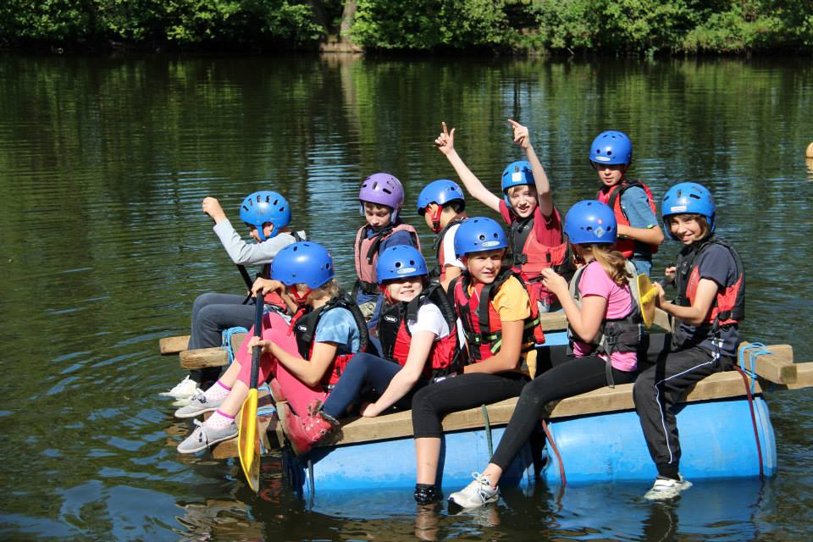

North Yorkshire Youth is a registered charity and exists to ‘to help children and young people realise their full potential by enhancing and improving our range of learning and development opportunities’.

That was the vision of our founders, way back in 1941, and it’s still our aim today.

We provide opportunities for children and young people to learn and grow by:

- Supporting youth work in North Yorkshire communities
- Providing adventurous activities from Carlton Lodge Activity Centre
- Providing training opportunities for young people and those who work with them.

Find out more at www.nyy.org.uk and www.carltonlodge.org.uk

Rural Arts

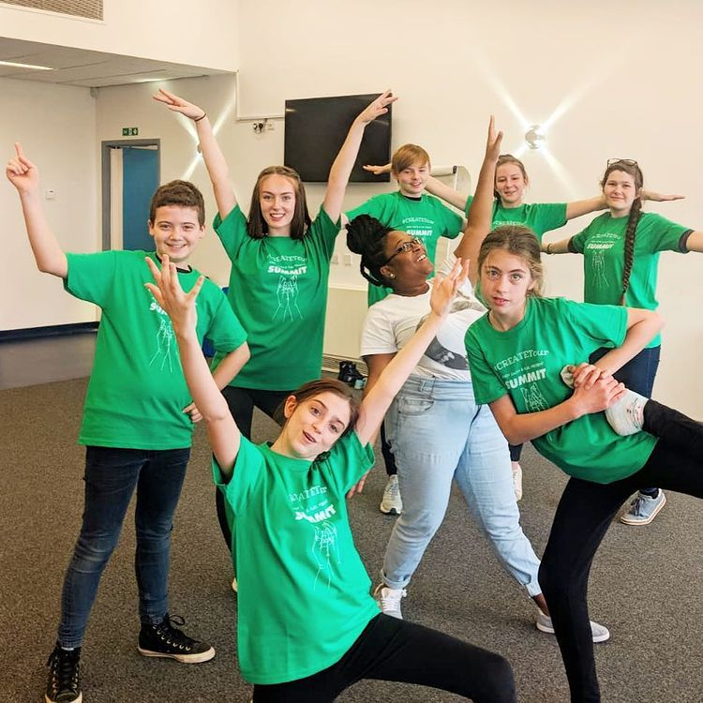

Rural Arts is a registered charity that delivers inspiring and inclusive creative opportunities that enrich lives and connect communities. Working across 3,500 square miles of England's largest county, our vision is creativity in every community in North Yorkshire.

We provide over 400 events and activities each year at The Courthouse, North Yorkshire's only professionally-run, cross-discipline arts centre, which is also home to an award-winning café, an artisan shop and rooms to hire.

We programme 70 professional performances per year in rural venues and lead a range of wellbeing and skills programmes to support isolated and vulnerable people. Rural Arts was founded in 1993 and is an Arts Council England National Portfolio Organisation.

Current Programmes

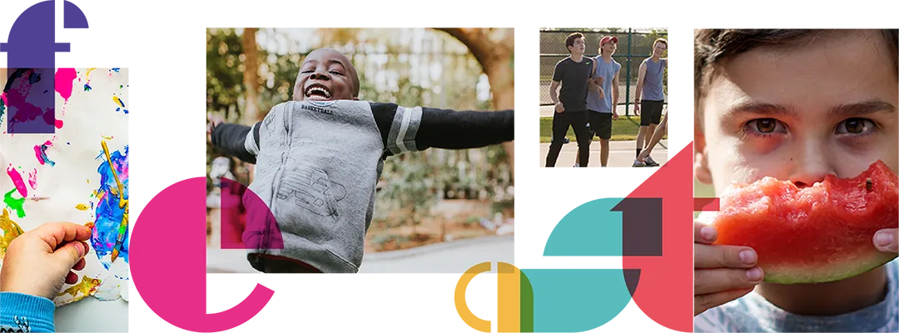

North Yorkshire Together develops and delivers support to communities that leverages the combined skills, experience and infrastructure of North Yorkshire Sport, North Yorkshire Youth, Rural Arts and additional partners, to have an impact that is greater than the sum of its parts and addresses existing gaps within community provision.

Our current programmes include FEAST, a refugee activity programme, and we’re a partner on Village Green, a North Yorkshire wide community-led climate change initiative.

- FEAST provides holiday activities with healthy meals to children and young people across the Easter, summer and Christmas holidays. We partner with leading activity providers across North Yorkshire to offer a wide range of activities for children and young people from Reception to Year 11, with free places for children and young people who receive benefits-related free school meals. Our involvement in Village Green will upskills activity providers and young people alike in climate justice. FEAST is North Yorkshire’s Holiday Activities and Food (HAF) programme, coordinated by North Yorkshire Together, who are commissioned by North Yorkshire Council through funding from the Department for Education.

- Our refugee activity programme supports families and individuals living in hotels in Selby and Northallerton with regular creative and physical activity, and connects them to other community-based activity.

Over the next year, we want to develop our next strategic and significant sized project to support North Yorkshire residents. This process will be led by our new Head of North Yorkshire Together.

North Yorkshire
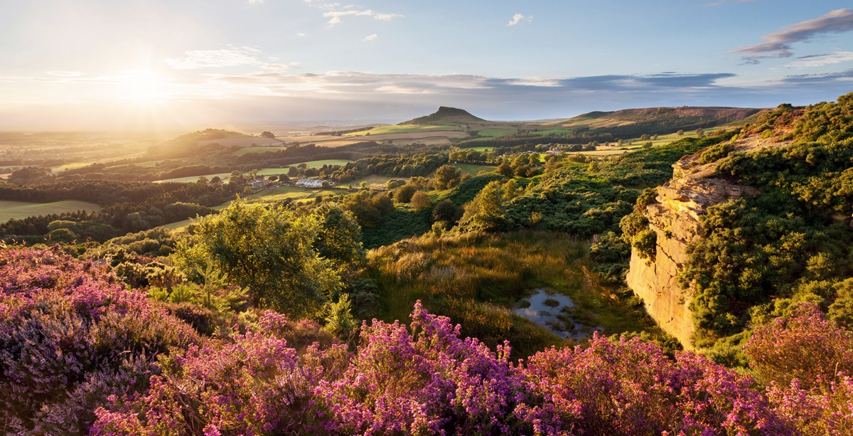
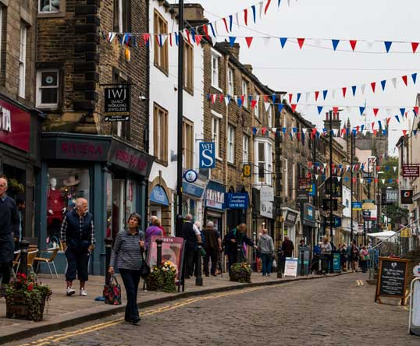
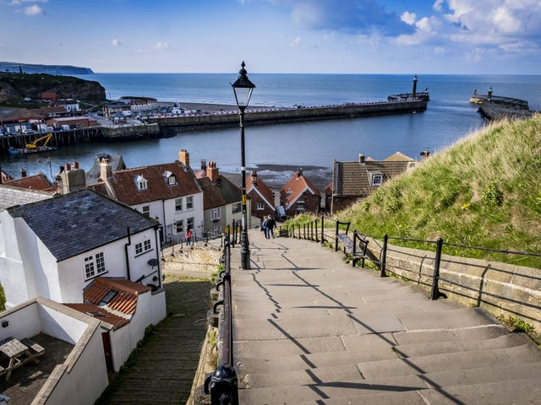
Top: A view across the North York Moors National Park. Bottom left: Whitby, a historic seaside town in the eastern district of Scarborough. Bottom right: The town of Skipton in the western district of Craven.

North Yorkshire is England’s largest county, spanning over 3,500 square miles – that’s three times the size of Luxembourg. 85% of this area is classified as ‘super sparse’ due to its intense rurality and low population density.

The county is home to stunning scenery and very friendly folk. It also faces significant and unique challenges: a ‘digital deficit’, an older population double the national average and three of England’s most deprived wards.

While 78% of people in North Yorkshire live rurally – four times the national average – North Yorkshire is home to a number of market towns and is easily accessible from towns and cities in neighbouring counties. You can find out more about North Yorkshire here.

The Role: Head of North Yorkshire Together

This is an exciting and unique opportunity to lead and develop North Yorkshire Together, which improves the lives of thousands of residents each year.

We’re looking for a VCSE professional with exceptional leadership and management skills, preferably with a deep existing understanding of North Yorkshire and its community and local government landscape. You will champion partnership working, embrace innovation and increase our profile. You will seek new opportunities for the partnership, extending our impact and visibility, and provide inspiration and direction to staff working on North Yorkshire Together projects across a number of organisations.

The core focus of this role is to develop and manage North Yorkshire Together and its programmes, serving as its key accountable person for project delivery, fundraising and finance, communications and advocacy. You will also offer support and guidance to staff employed by the partner organisations delivering on NYT programmes.

This role blends leadership and organisational development with programme management. As such, you will have strong written, presentational and digital skills. To be successful, you will need to manage competing deadlines and demands, have strong attention to detail and an ability to communicate effectively with internal and external stakeholders, representing both North Yorkshire Together and its partner organisations.

Main Responsibilities

Strategic Development & Delivery

- Develop and deliver, in discussion with NYT CEOs, programmes to support North Yorkshire residents to be happy and healthy
- Create and maintain an annual workplan, and provide project management for, aforementioned programmes
- Distil national policy, regional priorities and other developments into meaningful insights and tangible activity for the partnership
- Navigate opportunities and challenges, both for North Yorkshire and the partnership itself, dexterously and diplomatically
- Work with the voluntary and other sectors to gain a comprehensive understanding of the assets, opportunities and challenges affecting the region and its communities
- Develop and lead a fundraising strategy to ensure North Yorkshire Together’s sustainability and longevity
- Develop and drive a communications plan to ensure the visibility of North Yorkshire Together, our impact and partner organisations

Advocacy & Relationship Development

- Build relationships with key stakeholders including local authorities, public bodies, the VCSE sector, education, healthcare and more
- Maintain and sustain strong relationships with aforementioned stakeholders, including via monitoring and reporting to funders
- Be an inspiring and engaging ambassador for North Yorkshire Together, its partner organisations and the region, in various forums locally, regionally and nationally
- Utilise the networks and connections of North Yorkshire Together partner organisations to increase the impact and visibility of our work and partnership
- Serve on any regional or national boards to represent North Yorkshire Together, or champion the sector, as appropriate
- Lead North Yorkshire Together’s communications plan and output, in collaboration with NYT CEOs and marketing support

Governance

- Maintain financial oversight on all aspects of North Yorkshire Together
- Lead on the creation of written reports on behalf of North Yorkshire Together, including reporting to funders.
- Inform and brief North Yorkshire Together partners, where relevant, on relevant strategic developments, policies etc. affecting the sector or partnership
- Ensure all projects adhere to, and all staff working on NYT projects understand and follow, relevant policies and procedures
- Identify and implement, in close working with NYT CEOs, developments to North Yorkshire Together’s governance

General

- Oversee the operational management of North Yorkshire Together, including leading on areas such as administration and digital administrative governance elements, such as attendance log, location and timings of Board meetings, in discussion with the Chair
- Manage relationships with key external suppliers, such as marketing support, web hosting and development etc.
- Take initiative and self-direct (as required and within the remit of the role), to manage competing deadlines and demands.
- Work collaboratively, positively and effectively across North Yorkshire Together organisations, including with remote teams
- Demonstrate a commitment to the principles of equality of opportunity, inclusion, and fairness in all matters
- Work within relevant policies, procedures and insurances
- Ensure the Safeguarding needs of young people and vulnerable adults are managed, escalating concerns appropriately
- Uphold and embody the mission, vision and values of North Yorkshire Together and its partners, working transparently and with integrity
- To uphold and embody the mission, vision and values or North Yorkshire Youth and North Yorkshire Together
- To undertake other duties commensurate with this role, which may be required to further the work of North Yorkshire Together and its partners

About You: Person Specification

Below are the skills and experiences we’re looking for in our new Head of North Yorkshire Together.

Essential

- Exceptional strategic thinking and planning skills, evidenced by experience in a senior leadership or strategic role within the VCSE or other relevant sectors
- Deep understanding of the VCSE sector and its role in supporting communities
- Highly developed relationship-building and networking skills, including advocacy and negotiation
- Strong awareness of national policy and regional priorities, and ability to translate these into actionable programmes
- Demonstrable experience of developing and delivering impactful programmes that respond to community needs
- Ability to navigate complex challenges and opportunities with diplomacy and sound judgement, managing competing priorities and deadlines
- Proven track record of successful fundraising and financial management
- Strong written and verbal skills, with experience leading communications to raise organisational visibility
- Inspiring and credible leader, able to motivate and influence others, with experience of working collaboratively and in partnership across organisational boundaries
- Understanding of governance, compliance, and safeguarding requirements within the VCSE context
- Highly organised, proactive, and adaptable with proficiency in digital tools and administrative systems for operational management
- Diplomatic and resilient, with the ability to manage sensitive issues effectively
- Passionate about improving wellbeing of individuals and communities
- Commitment to equity, diversity, belonging and inclusion

Desirable

- Deep understanding of North Yorkshire, its communities, VCSE sector and local government landscape
- Degree-level education in a relevant field (e.g., leadership / management, social policy, community development). Equivalent work experience is equally valued.
- Understanding of systems leadership
- Experience submitting tenders or contracts, and working within funding relationships with local government

How to Apply

We want you to share with us why you’d be great for this role by completing our application form here.

If, for accessibility reasons, you need to apply in another way, please email recruitment@northyorkshiretogether.co.uk

In your application, please detail your suitability and experience specifically in relation to the role description and person specification.

Please also complete our Equal Opportunities monitoring form via the online application platform linked above.

The deadline for applications is 5pm on Thursday 12th February

If you have any questions, please email recruitment@northyorkshiretogether.co.uk

Interviews will take place on Friday 20th February in Harrogate

If this date or place is not possible for you, please tell us in your application.

We hope to let you know by 6pm, Monday 16th February if you are being invited to interview for the role. We will let you know if our timelines change, and you will hear from us no matter what the outcome of your application.

If your application is unsuccessful, we are happy to share with you the areas in which we felt your application could have been stronger.

What We’re Offering: Terms, Conditions and Benefits

Annual Salary: £40,00-£44,000 per annum (pro-rata, if applicable)

Hours: 37 hours per week, Monday – Friday, although for the right candidate we may consider 30 hours, worked across a minimum of four days, with a pro-rata salary. Occasional weekend and/or evening work may be required; Time Off in Lieu is given.

Employment type: Fixed term, most likely until 31st March 2029

Annual Leave: 25 days per annum (pro-rata) plus Bank Holidays

Benefits: A wide range of benefits is available to all staff directly employed by North Yorkshire Sport. More information can be found here.

Place of Work: Your usual place of work will be agreed in consultation with North Yorkshire Together as one of North Yorkshire Sport, North Yorkshire Youth or Rural Arts’ offices, in Harrogate or Thirsk respectively. You will also spend some time at North Yorkshire Council offices, and travelling around the county.

Championing Diversity

North Yorkshire Together strives to champion diversity in all its forms.

People from the global majority*, who are LGBTQIA+, disabled and/or from low socio-economic backgrounds are particularly encouraged to apply.

*This includes, but is not limited to, people of Black Caribbean, Black African, South Asian, East Asian, South East Asian, Middle Eastern, Arab, Latinx, Jewish, Romany and Irish Traveller heritage.

People from these groups are currently under-represented in management positions within the voluntary, community and social enterprise sector nationwide, and North Yorkshire Together is committed to challenging and changing this.

We are also particularly keen to hear from people who have lived experience of or affinity with rurality, rural isolation and/or the importance of youth work.

Please complete our Equal Opportunities monitoring form alongside your application to support our continued work in this area.

Accessibility

If you require this or any further information in an alternative format, please contact recruitment@northyorkshiretogether.co.uk

An audio recording of this pack can be provided upon request.

You are encouraged to share any access requirements you may have at the interview stage in the covering email/letter of your application.

